═══ NASA TLX Cognitive Workload Analysis ═══
File: c:\Users\mirey\Documents\Github\study-inaccessible-interface\index.html
Language: html | Lines: 584 | Chars: 29016
Model: kimi-k2.5:cloud | RAG: https://proven-specks-badge.ngrok-free.dev
RAG: 10 chunk(s) in 631 ms
TLX Workload Analysis
Mental Demand80/100
Confidence: 92%
Empty aria-labels, non-descriptive link text ("click here"), missing form labels, and placeholder-only inputs force users to infer context and remember field purposes, significantly increasing perceptual and cognitive processing.
Physical Demand35/100
Confidence: 88%
While interaction relies on standard clicks and keyboard navigation, the lengthy single-page structure (584 lines) requires extensive scrolling; however, no complex gestures or precise motor control is demanded beyond typical web browsing.
Temporal Demand15/100
Confidence: 95%
No time constraints, auto-refreshing elements, or countdown timers are present, allowing users to navigate and complete tasks at their own pace without time pressure.
Performance75/100
Confidence: 90%
Significant barriers to task success exist due to missing form labels, ambiguous link purposes, and poor table semantics (td used instead of th), causing users to struggle with form completion and navigation.
Effort78/100
Confidence: 91%
Users must work considerably to compensate for accessibility deficiencies, including deciphering placeholder-only fields, interpreting vague link destinations, and navigating redundant content sections (duplicate Security section).
Frustration82/100
Confidence: 93%
Completed in 19470 ms (first token: 17587 ms)
NASA-TLX Assessment
Dimension | Rating | Confidence
Mental Demand | 80/100 | 92%
Physical Demand | 35/100 | 88%
Temporal Demand | 15/100 | 95%
Performance | 75/100 | 90%
Effort | 78/100 | 91%
Frustration | 82/100 | 93%
Overall Cognitive Load: 60.8/100

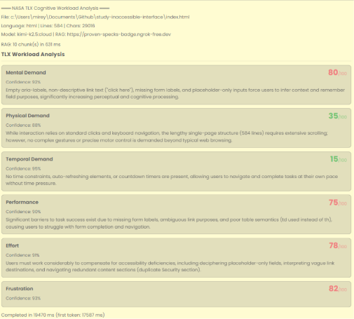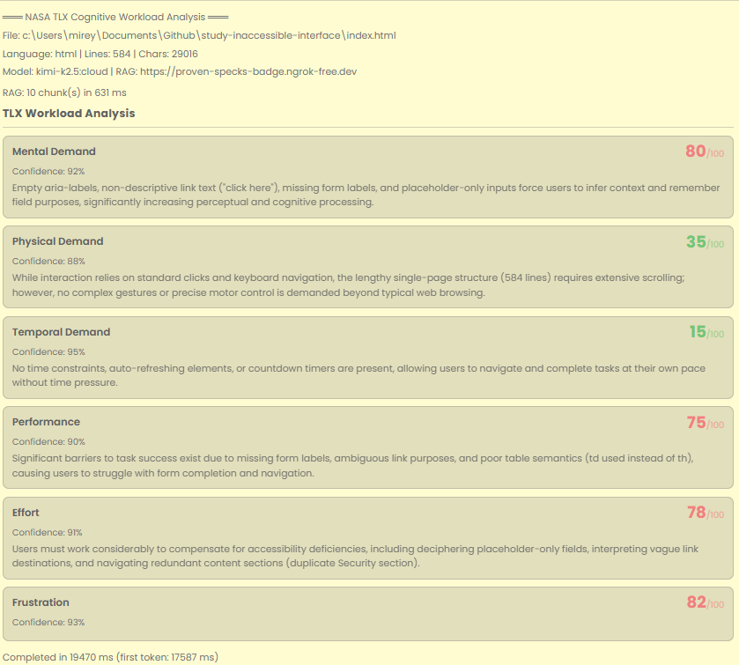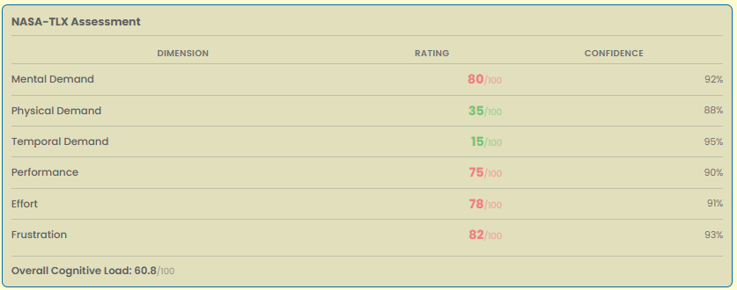

═══ NASA TLX Cognitive Workload Analysis ═══
File: c:\Users\mirey\Documents\Github\study-accessible-interface\index.html
Language: html | Lines: 634 | Chars: 34280
Model: kimi-k2.5:cloud | RAG: https://proven-specks-badge.ngrok-free.dev
RAG: 10 chunk(s) in 520 ms
TLX Workload Analysis
Mental Demand30/100
Confidence: 90%
Extensive content density requires information processing, but clear semantic HTML structure, logical heading hierarchy, and organized sections minimize cognitive branching and ambiguity.
Physical Demand10/100
Confidence: 95%
Standard web interactions only; skip links reduce tabbing burden, keyboard navigation is fully supported, and no complex gestures or precise motor control are required.
Temporal Demand5/100
Confidence: 95%
No time limits, session timeouts, or auto-refreshing content are present; users can navigate and consume information at their own pace without pressure.
Performance10/100
Confidence: 90%
High task completion success is expected due to WCAG 2.2 AA compliance, proper ARIA labeling, semantic structure, and clear navigation paths that minimize barriers.
Effort15/100
Confidence: 90%
Minimal mental and physical work required due to accessible design patterns including skip links, descriptive labels, logical content flow, and clear visual organization.
Frustration10/100
Confidence: 85%
Completed in 15875 ms (first token: 14088 ms)
NASA-TLX Assessment
Dimension | Rating | Confidence
Mental Demand | 30/100 | 90%
Physical Demand | 10/100 | 95%
Temporal Demand | 5/100 | 95%
Performance | 10/100 | 90%
Effort | 15/100 | 90%
Frustration | 10/100 | 85%
Overall Cognitive Load: 13.3/100


